**Team Name – Tech Knights**

**Team Members**

695275 – Vivek Baskaran

673821 – Durga Devi Ganesan

732119 – Tamilarasan M

**ONLINE FOOD MANAGEMENT SYSTEM**

|  |  |
| --- | --- |
|  |  |
|  |

**ABSTRACT**  
  
 The online food ordering system provides convenience for the customers. It overcomes the disadvantages of the traditional queuing system. This system increases the takeaway of foods than visitors. Therefore, this system enhances the speed and standardization of taking the order from the customer. It provides a better communication platform. The user’s details are noted electronically.   
 The online food ordering system set up menu online and the customers easily places the order with a simple mouse click or screen touch. Also with a food menu online you can easily maintain customer's database and improve your food delivery service. This system allows the user to select the hotel and the desired food items from the displayed menu. The user orders the food items. The delivery boy can pick up the item and delivery the item to the customer. The payment can be made online or pay-on-delivery system. The user’s details are maintained confidential because it maintains a separate account for each user. An id and password is provided for each user. Therefore, it provides a more secured ordering.

**Existing System:**

In existing system for giving any orders users should visit Food court to know about food items and them give order and pay advance.  In this method time and manual work is required. Maintaining critical information in the files and manuals is full of risk and a tedious process.

**Proposed System:**

This online application enables the vendor, delivery boy and customer to register online with the permission of Admin, Then the vendor can add their items now the customer can select the food from the e-menu, read the E-menu and order food online. The customer can add addons for the item like add extra cheese …etc. Delivery boy will pick up the item from vendor and deliver the item to the customer. By just selecting the food that the customer wants to have. By using this application, the work of the Waiter is reduced and we can also say that the work is nullified. The benefit of this is that if there is rush in the Restaurant then there will be chances that the waiters will be unavailable and the users can directly order the food to the vendor online by using this application.

**Roles and Functionalities:**

* Admin
* Vendor
* Customer
* Delivery Boy

**Admin**

Admin is the controller of this application. Admin provide the permission to access the application for vendor, customer and delivery boy. Admin can view all the information about the vendor, customer and delivery boy or delete or edit the all details.

This Functionalities provided:

* Approve the registration
* Mange Vendor, Customer and delivery boy details
* View orders

**Vendor**

Vendor can register about the hotels. Once the vendor gets the permission from the Admin he can add, edit and delete the items details. Once the order is placed, the vendor sent the confirmation to the customer. The vendor delivered the prepared item to the Delivery boy.

This Functionalities provided:

* Register
* Login
* Add product’s list
* Pickup orders / Order confirmation
* Deliver orders
* View feedbacks for the items
* Order History

**Customer**

Customer can register his/her details. Once the customer gets the permission from the Admin he can add, edit and delete the items details in his/her cart. And also he can add favorite items and hotels. Once the order is placed, the Customer will get confirmation notification from the vendor. The payment may be done by online transaction (Debit card / credit card / net banking) or cash on delivery. Once the payment is done the customer can get the ordered item from Delivery boy. The customer can give his/her valuable feedbacks to the items.

This Functionalities provided:

* Register
* Login
* View product’s list
* Add favorite Hotel
* Add favorite item
* View Hot deals
* Place orders
* Payment
* View Order history
* Give Review for ordered item

**Delivery Boy**

Delivery Boy can register his details. The Delivery Boy gets the permission from the Admin he can edit his profile. Once the ordered item is prepared he can get the notification regarding the ordered item. Once he picked up the order he can’t get another order. If he delivered the item, then only he can pick up the another order. The payment may be done by online transaction (Debit card / credit card / net banking) or cash on delivery. Once the payment is done the customer can get the ordered item from Delivery boy. The Delivery boy can get his/her valuable feedbacks from the customer.

Functionalities provided:

* Register
* Login
* Pickup orders
* Deliver orders
* View History of delivered items
* View feedbacks

**HARDWARE AND SOFTWARE REQUIREMENTS**

### Hardware Requirement:

* Hardware - Pentium
* Speed - 1.1 GHz
* RAM - 4 GB
* Hard Disk - 20 GB
* Floppy Drive - 1.44 MB
* Key Board - Standard Windows Keyboard
* Mouse - Two or Three Button Mouse
* Monitor - SVGA

### Software Requirements:

* Operating System : Windows
* Technology : MEAN Stack
* Web Technologies : Html, JavaScript, CSS
* IDE : Visual Studio Code
* Database : MongoDB

# WIREFRAMES

## Vendor Registration Page

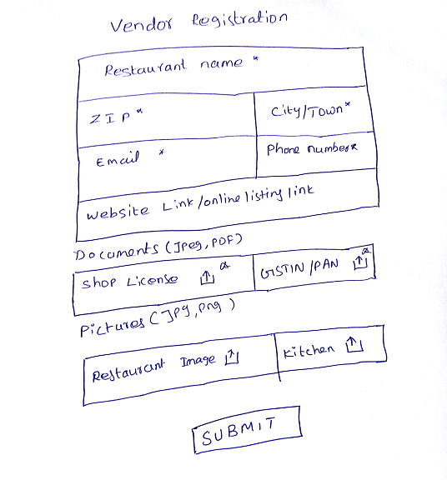

## Login Page

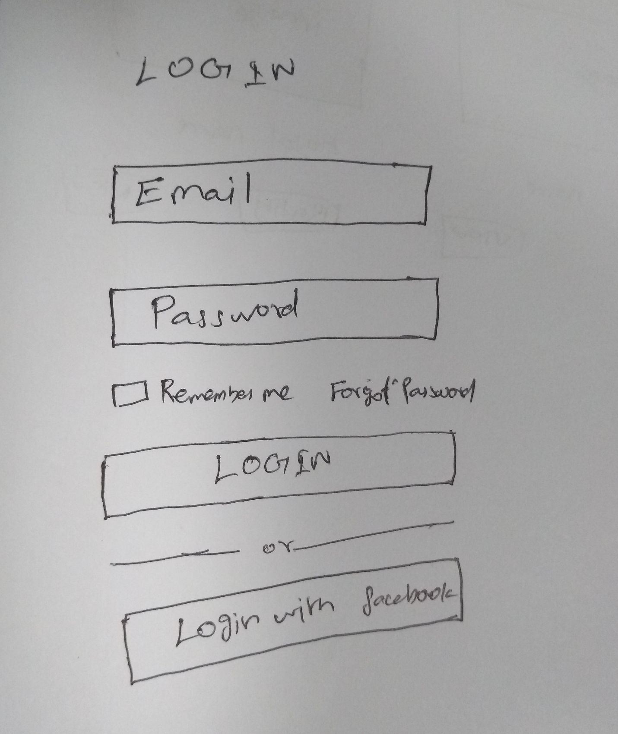

## Customer Reagistration Page

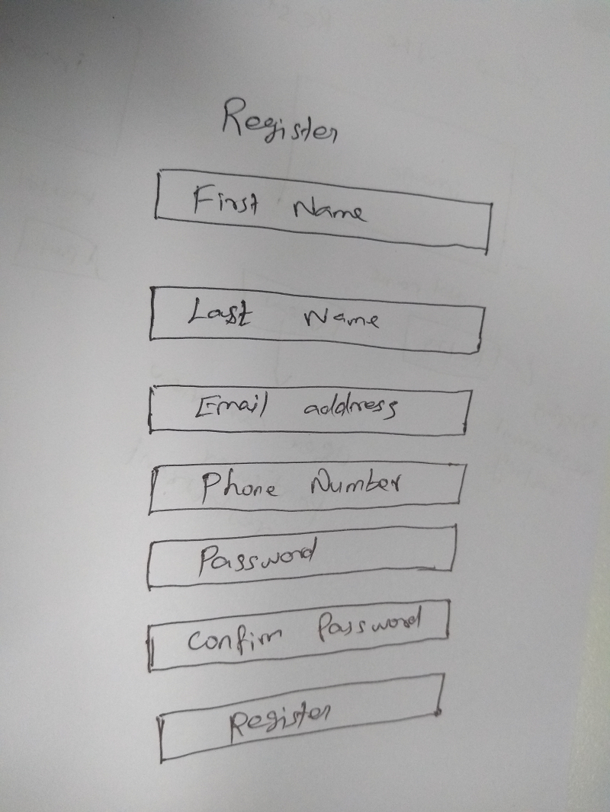

## Customer Profile Edit page

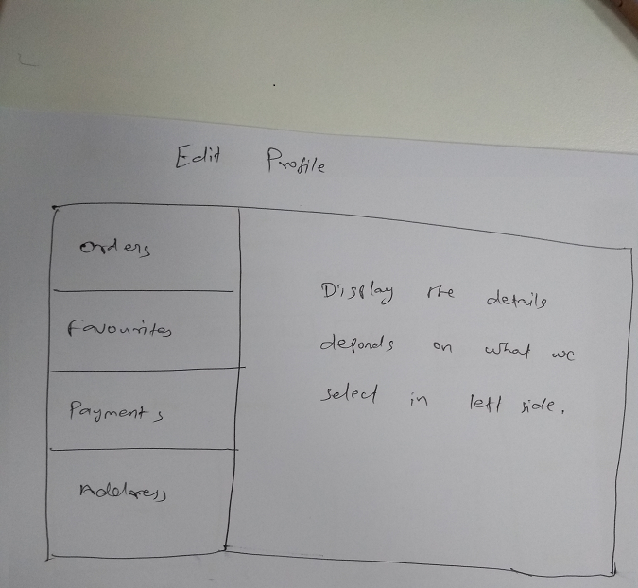

**Search Order Page**

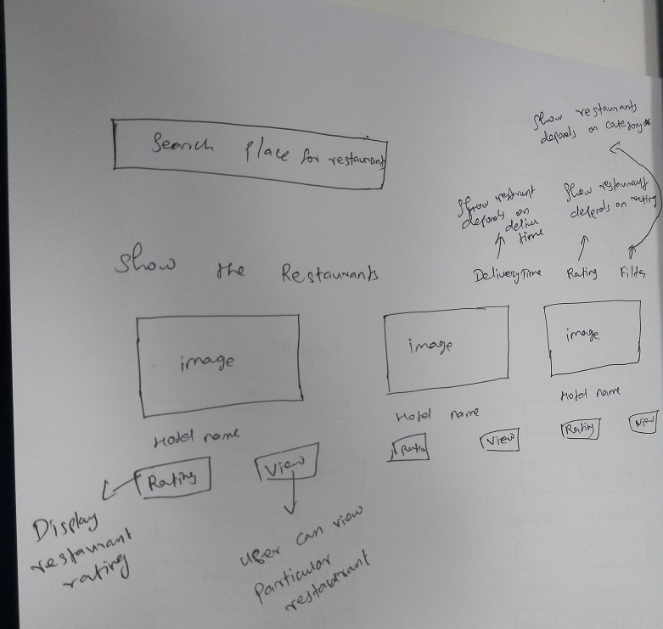

**Restaurant Details Page**

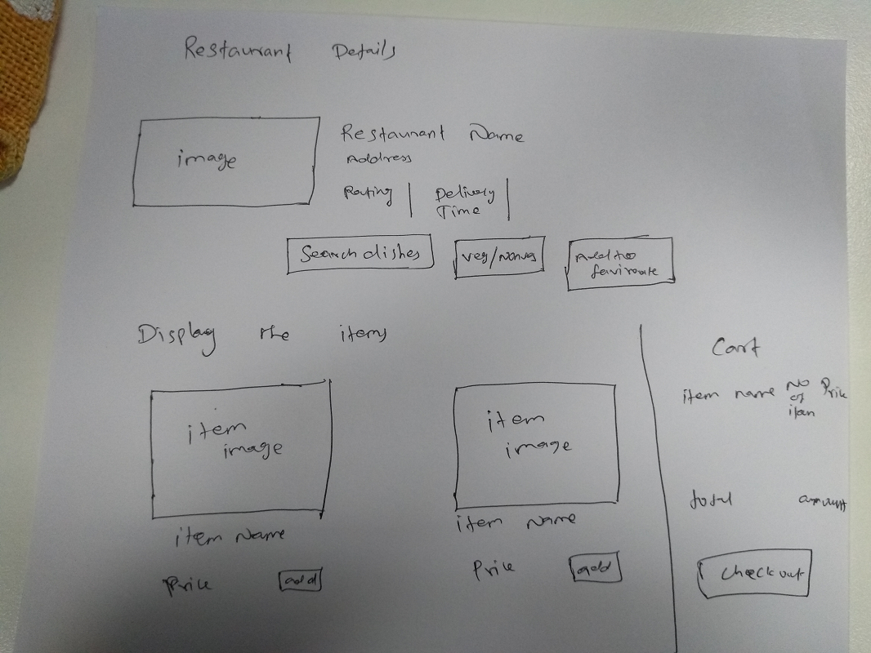

## Admin Searches Vendor Page

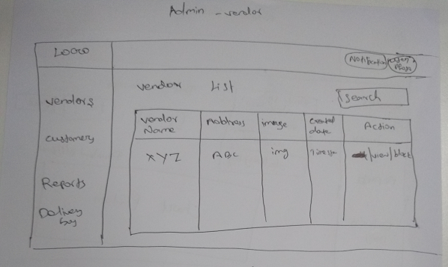

## Admin Views Vendor page

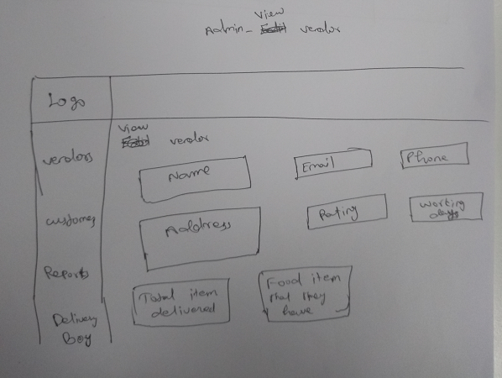

## Admin views vendor’s report Page

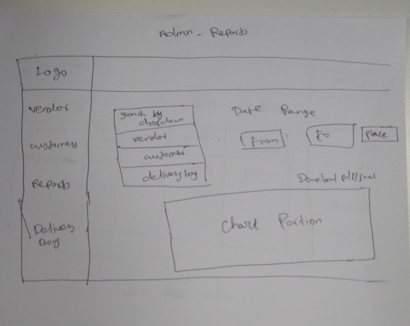

## Admin Searches Delivery Boy Page

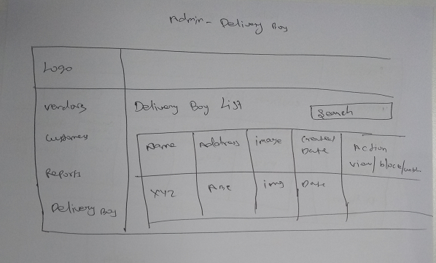

## Admin views Delivery Boy Page

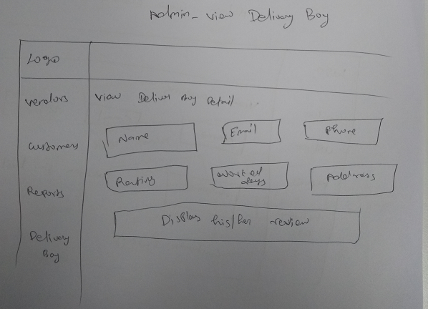

## Admin Searches Customer Page

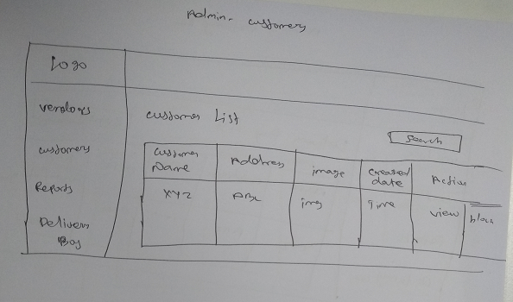

## Admin Views Customer Page

